SSC-W11490
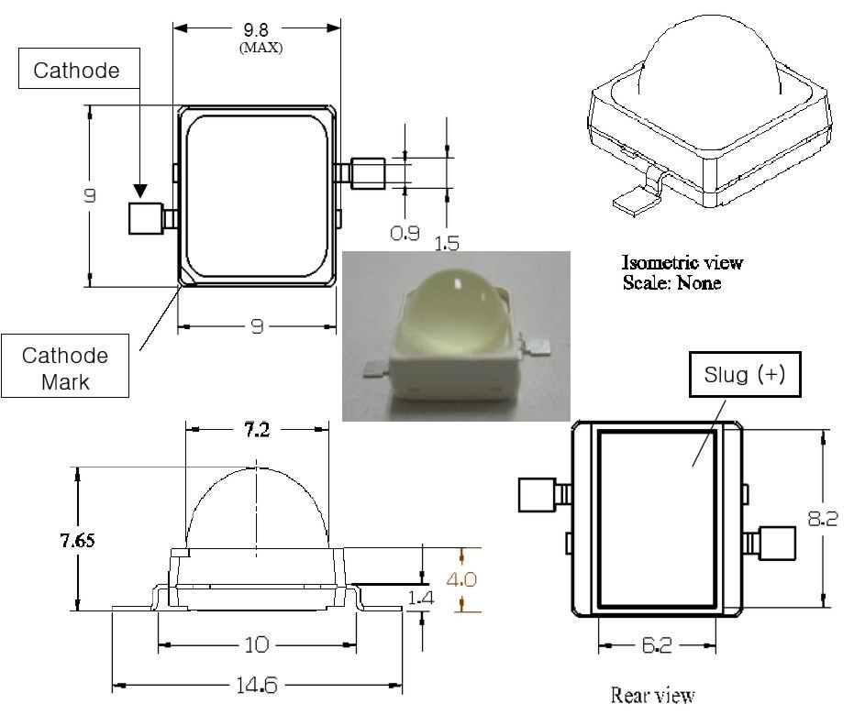

ML-P08M-ZRC; ML-P08M-ZWC; ML-P08M-ZWWC; ML-P08M-ZPC; ML-P08M-ZRC-3CX; ML-P08M-ZYC-3CX; ML-P08M-ZWWC-3CX
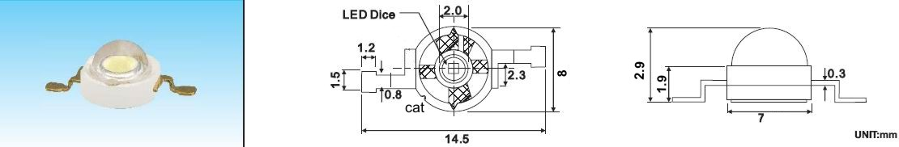

GV-PB8-48KB; GV-PB8-44KY
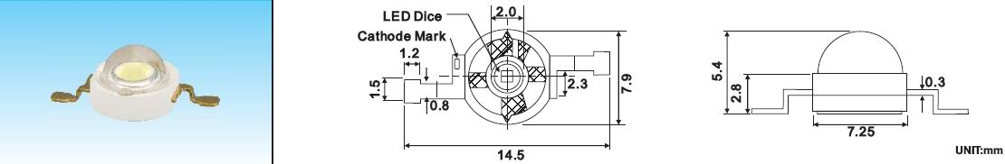

ML-P08M-ZRC/PCB; ML-P08M-ZWC/PCB; ML-P08M-ZWWC/PCB; ML-P08M-ZPC/PCB;
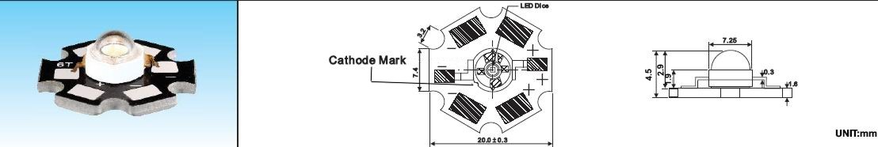
GV-PB8-48KB/PCB; GV-PB8-44KY/PCB
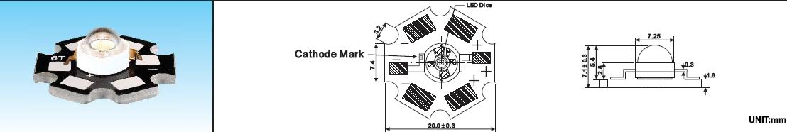

LW-HP-R3/PCB; LW-HP-G3/PCB; LW-HP-B3/PCB
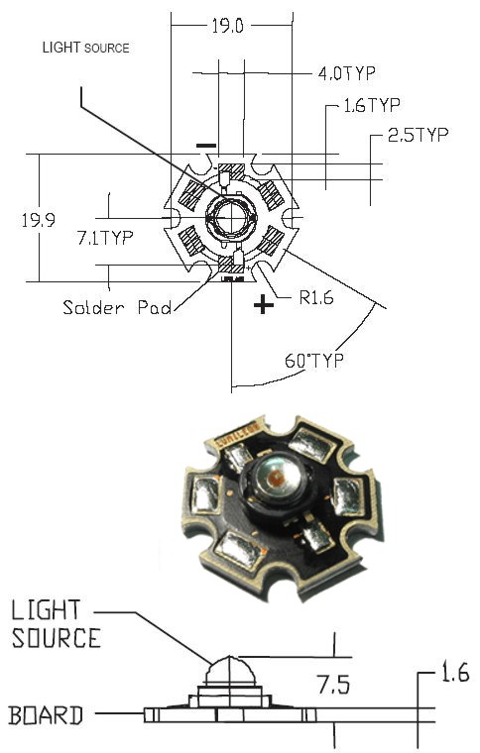

GV-PR20D-19K10W
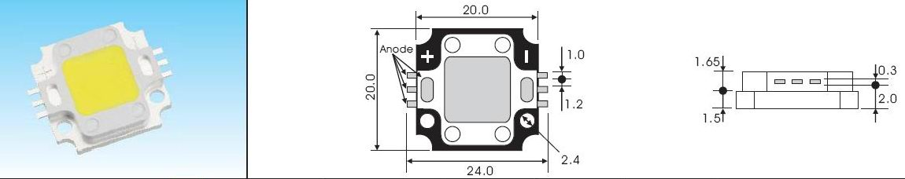
SMD 1206
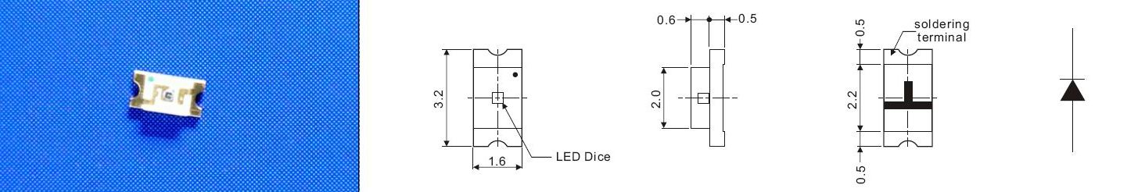

SMD 0603
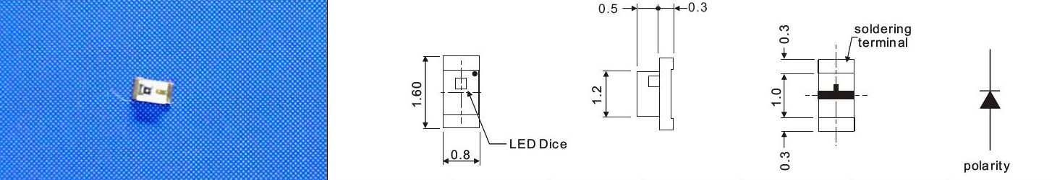

10mm
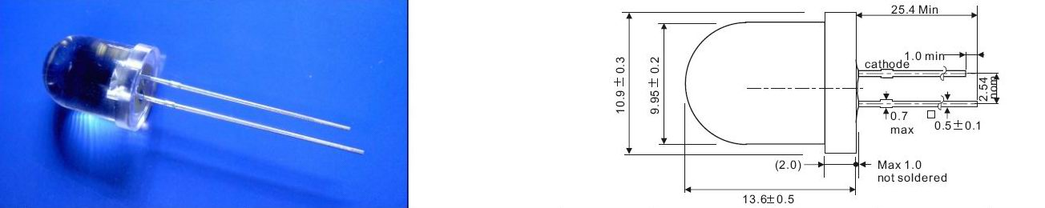

3mm
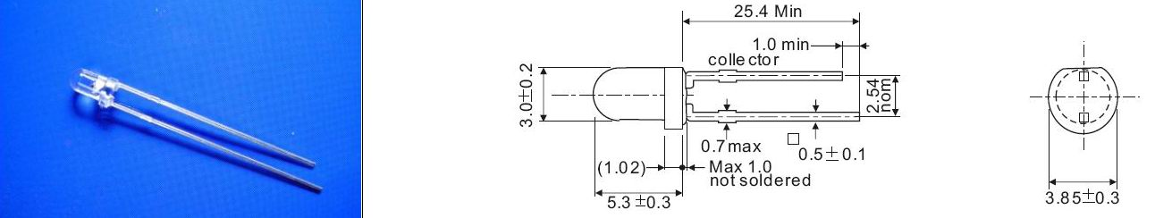

5mm
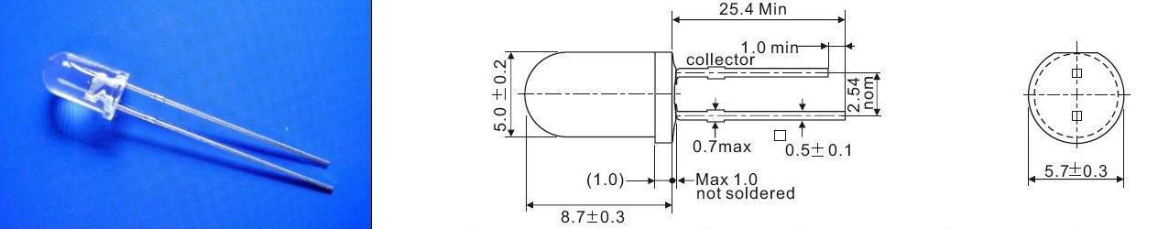

5mm hegyes
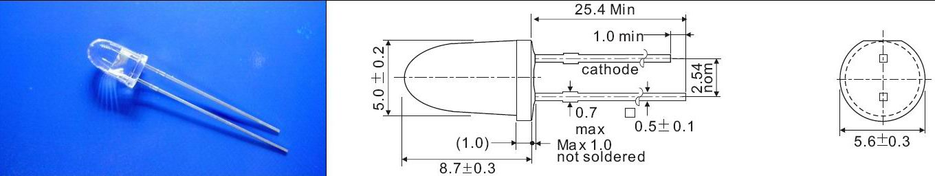

5mm oval
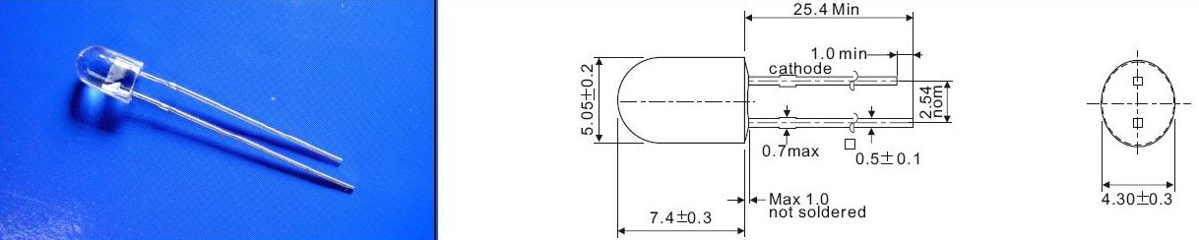

Super Flux 3mm
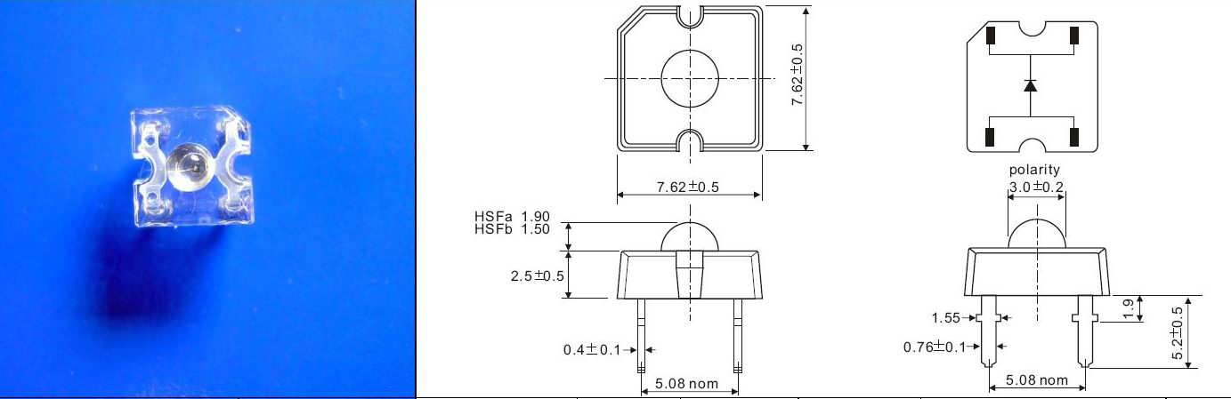

Super Flux 5mm
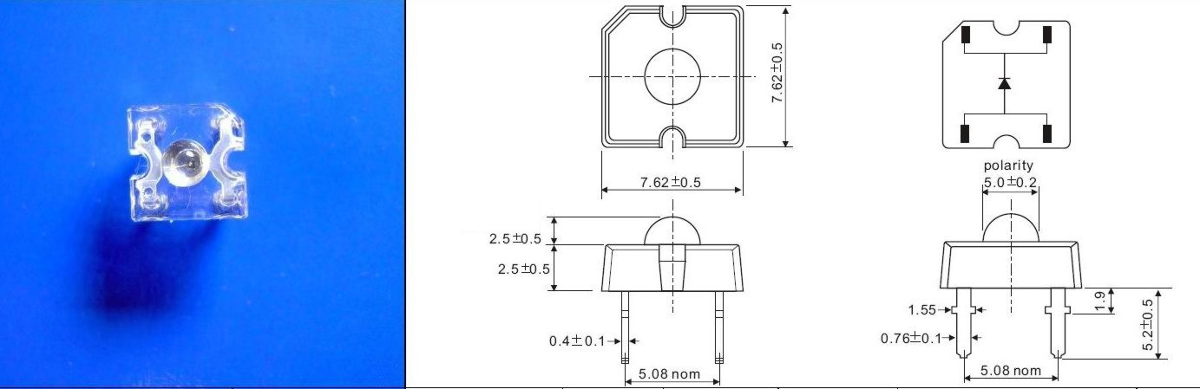

Super flux 120°
